Sample for PE  
SPRING 20  
Subject: WED201c  
Duration: 120 minutes

**Objectives:**

1. Create a style sheet and link it to the html files. **(Without changing the html)**
2. Create a file named yourCode.js and link it to the html files **(Without changing the html)**

**Background:**

In this practice exam, you are given a folder “**Resource**”. You are going to use two pages “index.html” and “teams.html” to finish the exam.

**Before styling index.html page**

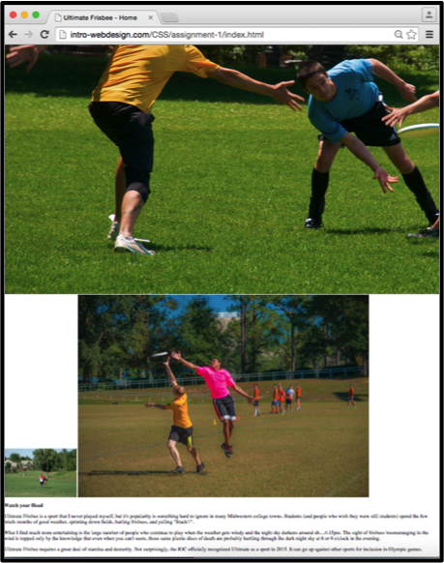

**After styling index.html page**

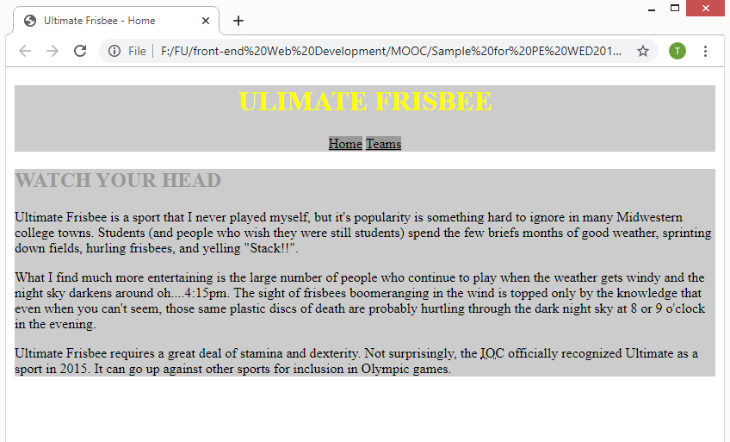

**After styling teams.html page**

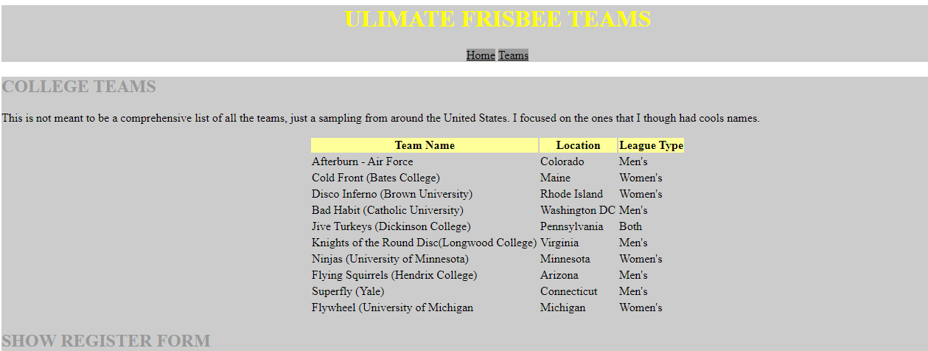

**After the user clicks on the text “SHOW REGISTER FORM”**

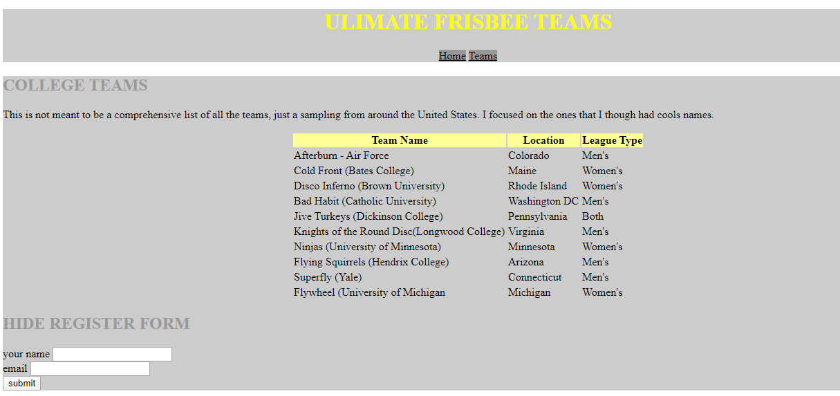

**Required:**

1. Create a file called **hw1.css** and save it in a given **Resource/css folder.**
2. Create a file called **yourCode.js** and save it in a given **Resource/js folder.**
3. In file hw1.css, using the properties color, background-color, text-align, text-transform, and/or display,… to style two pages “index.html” and “teams.html”. You can view the styled pages in folder “**Template**”
4. In file yourCode.js, using JavaScript language to display or hide the table.

**Evaluation:**

**A. CSS [ 5 marks]**

* Header, h1, nav tags should are designed with a good look [0.5points]
* Three images are hidden [0.5 points ]
* Section tag in index page is designed like the example given [2 points]
* Section tag in teams page is designed like the example given [2 points]

1. **Javascript [5marks]**

* You are required to complete the method “Show()”. In this method you have to do:
  + When the user clicks on the text “Show Register Form” (in the tag h2) then the form will be displayed and the inner html of tag h2 is changed to “Hide Register Form” [2 marks]
  + When the user clicks on the text “Hide Register Form” (in the tag h2) then the form will be hidden and the inner html of tag h2 is changed to “Show Register Form” [1. 5 marks]
* You are required to complete the method “checkForm()”. In this method you have to do:
  + two text fields are not empty [1.5 marks]

The end